**TOPIC: HUMAN REPRODUCTION AND REPRODUCTIVE HEALTH**

**UNIT NO: B-12**

1. Which of the following approaches does not give the defined action of contraceptive?

1. Intra-uterine Increase phagocytosis of sperms, devices suppress sperm motility and fertilising capacity of sperms

2. Hormonal Prevent/ retard entry of sperms, prevent contraceptives ovulation and fertilisation

3. Vasectomy Prevents spermatogenesis 4. Barrier methods Prevent fertilization

1. MTP is of much risk in which phase of the pregnancy?

1. 2nd trimester 2.1st trimester 3.1st week 4. 2nd week

1. Incidents of STD are very high among persons, in the age group of

1. 15-35 years 2.15-30 years 3.15-24 years 4. 15-45 year

1. Assertion (A): Contraceptives are methods to prevent unwanted pregnancies.

Reason (R): Unwanted pregnancies can only be prevented by using oral contraceptives

1. Both A and R are true and R is correct explanation of A

2. Both A and R are true, but R is not a correct explanation of A

3. A is true, but R is false 4. Both A and R are false

1. What is true about ‘Saheli’?

I. Developed at CDRI, Lucknow. II. Contains a steroidal preparation.

III. ‘Once-a-week’pill. IV. Many side effects.

V. High contraceptive value. VI. Very few side effects.

VII. Low contraceptive value.

1. I, II, III, V and VI 2. I, III, V and VI 3. I, II, III, IV and V 4. I, III, IV and V

1. Later complications of STDs are

I. Pelvic inflammation disease. II. Abortion. III. Still birth.

IV. Ectopic pregnancies. V. Infertility. VI. Cancer.

Choose the correct combinations.

1. I, II, III, IV and V 2. I, II, III, V and VI 3. I, III, IV, V and VI 4. All of these

|  |  |  |  |  |  |
| --- | --- | --- | --- | --- | --- |
|  | A | B | C | D | E |
| 1. | 1 | 3 | 2 | 4 | 5 |
| 2. | 4 | 5 | 3 | 2 | 1 |
| 3. | 1 | 2 | 3 | 4 | 5 |
| 4. | 1 | 2 | 4 | 3 | 5 |

1. Match the following columns.

|  |  |
| --- | --- |
| Column I (STD) | Column II (Causal Agent) |
| A. Chlamydiasis | 1. *Chlamydia trachomatis* |
| B. Gonorrhoea | 2. *Neisseria gonorrhoeae* |
| C. Trichomoniasis | 3. *Trichomonasvaginalis* |
| D. Genital herpes | 4. Herpes simplex virus |
| E. Syphilis | 5. *Treponemapallidum* |

1. Intensely lactating mothers do not generally conceive due to the

1. Suppression of gonadotropins 2. Hypersecretion of gonadotropins

3. Suppression of gametic transport 4.Suppression of fertilization

1. Following statements are given regarding MTP. Choose the correct options given below.

I. MTPs are generally advised during first trimester

II. MTPs are used as a contraceptive method.

III. MTPs are always surgical.

IV. MTPs require the assistance of qualified medical personnel.

Codes

1. I and III 2. II and III 3. I and IV 4. I and II

1. Match the following columns.

|  |  |
| --- | --- |
| Column I | Column II |
| A. Government of India legalised MTP | 1. 1951 |
| B. Family planning introduced in India | 2. 1971 |
| C. Lactational-Amenorrhoea | 3. Natural contraceptive |
| D. IUD | 4. Progesterone |
| E. Pill | 5. Cu-T |

|  |  |  |  |  |  |
| --- | --- | --- | --- | --- | --- |
|  | A | B | C | D | E |
| 1. | 1 | 2 | 3 | 4 | 5 |
| 2. | 2 | 1 | 3 | 5 | 4 |
| 3. | 4 | 3 | 2 | 1 | 5 |
| 4. | 5 | 4 | 3 | 2 | 1 |

1. Sterilisation techniques are generally fool proof methods of contraception with least side effects. Yet, this is the last option for the couples because

I. It is almost irreversible.

II. Of the misconception that it will reduce sexual urge/drive

III. It is a surgical procedure.

IV. Of lack of sufficient facilities in many parts of the country.

Choose the correct option.

1. I and III 2. II and III 3. II and IV 4. 1, II, III and IV

1. A national level approach to build up a reproductively healthy society was taken up in our country in

1. 1950s 2.1960s 3.1980s 4. 1990s

1. Condoms are one of the most popular contraceptives because of the following reasons.

1. These are effective barriers for insemination

2. They do not interfere with coital act

3. These help in reducing the risk of STDs 4. All of the above

1. Which statement is true about diaphragm?

1. They are introduced into the uterus

2. They are placed to cover the cervical region

3. They act as chemical barriers for sperm entry

4. They act as spermicidal agents

1. Emergency contraceptives are effective if used within72 hrs of

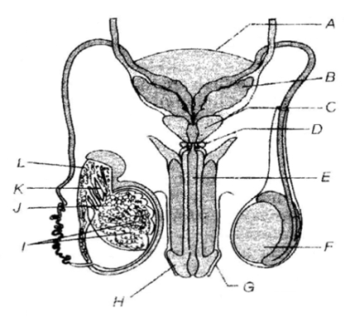1. Coitus 2. Ovulation 3. Menstruation 4. Implantation

1. Identify A, B, C and D in the given diagram.

1. A - Urinary bladder, B- Bulbourethral gland,

C – Prostate gland, D- Seminal vesicles

2. A-Urinary bladder, B -Seminal vesicles,

C-Prostate gland, D-Bulbourethral gland

3. A-Prostate gland, B - Seminal vesicles,

C – Urinary bladder, D-Bulbourethral gland

4. A - Bulbourethral gland, B - Urinary bladder,

C-Seminal vesicles, D - Prostate gland

1. Increased IMR and decreased MMR in a population will

1. Cause rapid increase in growth rate 2. Result in decline in growth rate

3. Not cause significant change in growth rate 4. Result in an explosive population

1. Choose the right one among the statements given below.

1. IUDs are generally inserted by the user herself

2. IUDs increase phagocytosis reaction in the uterus

3. IUDs suppress gametogenesis

4. IUDs once inserted need not be replaced

1. 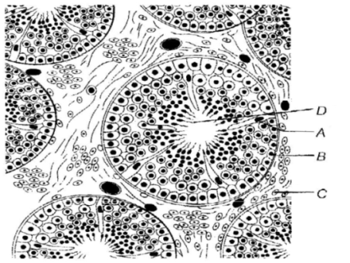The given diagram refers to T.S of testis showing sectional view of a few seminiferous tubules.   
   Identify the parts labelled A-D and select the correct option.

1. A - Sertoli cells, B - Spermatozoa,

C-Interstitial cells, D-Sperms

2. A- Sertoli cells, B-Secondary spermatocyte,

C-Interstitial cells, D-Sperms

3. A-Interstitial cells, B-Spermatogonia,

C-Sertoli cells, D-Sperms

4. A-Sertoli cells, B-Spermatogonia,

C - Interstitial cell, D-Sperms

1. From the sexually transmitted diseases mentioned below, identify the one which does not specifically affect the sex organs.

1. Syphilis 2. AIDS 3. Gonorrhoea 4. Genital warts

1. Choose the correct statement regarding the Z1FTprocedure.

1. Ova collected from a female donor are transferred to the Fallopian tube to facilitate zygote formation

2. Zygote is collected from a female donor and transferred to the Fallopian tube

3. Zygote is collected from a female donor and transferred to the uterus

4. Ova collected from a female donor and transferred to the uterus

1. The correct surgical procedure as a contraceptive method is

1. Ovariectomy 2.Hysterectomy 3.Vasectomy 4. Castration

1. The following diagram refers to female reproductive system of human. Identify A to E.

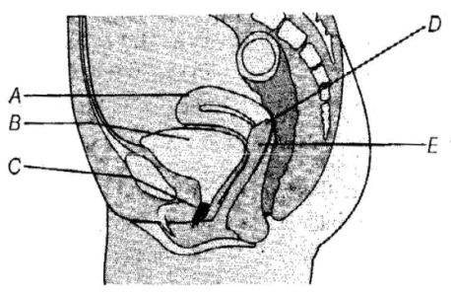1. A-Urethra, B-Urinary bladder, C-Uterus,

D-Cervix, E-Vagina

2. A-Urethra, B-Urinary bladder, C-Uterus,

D-Vagina, E-Cervix

3. A-Urethra, B- Urinary bladder, C-Uterus,

D-Cervix, E-Vagina

4. A- Uterus, B-Urinary bladder, C-Urethra,

D-Cervix, E-Vagina

1. The method of directly injecting a sperm into ovum in assisted by reproductive technology is called

1. GIFT 2. ZIFT 3. ICSI 4. FT

1. The following diagram refers to the female reproductive system of humans. Identify A to F.

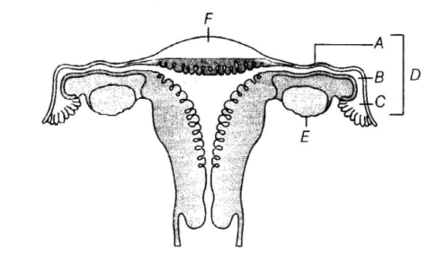1. A-Ampulla, B-Isthmus, C- Infundibulum,

D-Fallopian tube, E-Ovary, F-Uterine fundus

2. A-Isthmus, B-Infundibulum, C-Ampulla,

D-Fallopian tube, E-Ovary, F-Uterine fundus

3. A-Isthmus, B-Ampulla, C-Infundibulum,

D-Fallopian tube, E-Ovary, F-Uterine fundus

4. A-Ampulla, B-Infundibulum, C-Isthmus,

D-Fallopian tube, E-Ovary, F-Uterine fundus

1. Given the diagrammatic sectional view of mammary gland. Identify A, B, C and D

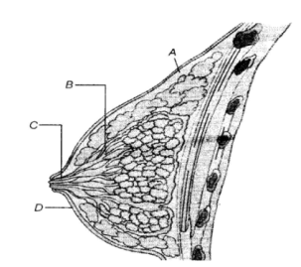1. A-Alveolus, B-Mammary duct, C-Lactiferous duct,

D-Areola

2. A-Alveolus, B-Lactiferous duct, C-Mammary duct,

D-Areola

3. A-Alveolus, B-Mammary duct, C-Lactiferous duct,

D-Lactogenic spot

4. A-Mammary gland, B-Mammary duct, C-Lactiferous duct, D-Areola

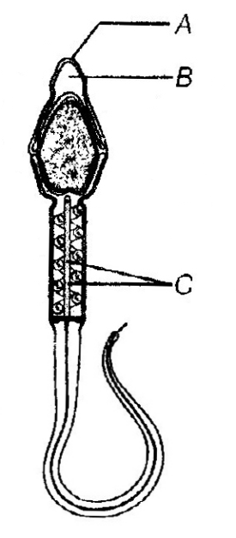

1. Identify A, B and C in the given human sperm, diagram.

1. A-Acrosome, B-Plasma membrane, C-Mitochondria

2. A Plasma membrane, B-Acrosome, C-Mitochondria

3. A-Mitochondria, B- Acrosome, C- Plasma membrane

4. A-Mitochondria, B Plasma membrane, C-Acrosome

1. 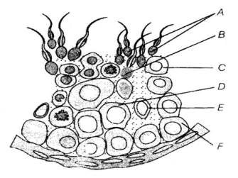Find out spermatid and sertoli cell in given below diagram.

1. D and E

2. E and F

3. A and C

4. B and E

1. 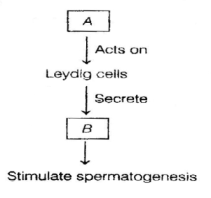Give the name of two hormones A and B in the figure given below.

1. FSH and GH

2. LH and Androgens

3. GH and LH

4. GH and Lactin

1. Read the graph and correlate the uterine events that take place according to the hormonal levels on A. 6-15 days, B. 16-25 days, C. 26-28 days (if the ovum is not fertilised).

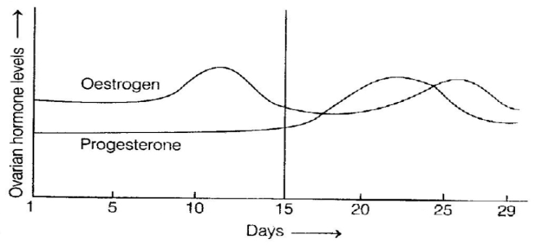

1. A-Degeneration of endometrium, B Myometrium thickness, becomes vascularised ready to receive and implant embryo, C-Regeneration of endometrium

2. A-Degeneration of endometrium, B-Endometrium thickness increases, becomes vascularised, ready to receive and implant ovum, C-Regeneration of endometrium

3. A-Regeneration of endometrium, B-Endometrium becomes thick and vascularised ready to receive andimplant embryo, C-Degeneration of endometrium

4. A-Regeneration of myometrium, B-Endometrium becomes thick and vascularised, ready to receive and implant embryo, C-Degeneration of endometrium

1. 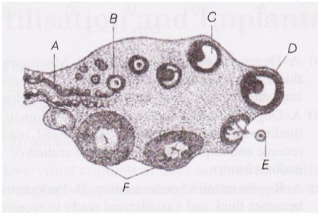Give the name of C and D in the diagram.

1. Secondary spermatocyte and primary spermatocytes

2. Tertiary follicles showing antrum and Graafian follicle

3. Primary spermatocyte and secondary spermatocytes

4. Graafian follicle and ovum

1. 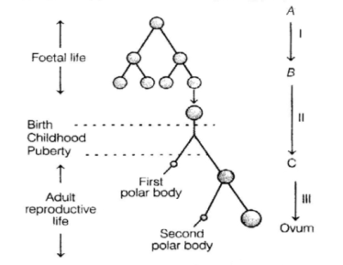Identify of A, B and C in the figure given below

1. A-Secondary oocyte, B-Oogonia, C-Primary oocyte

2. A-Oogonia, B-Primary oocyte, C-Secondary oocyte

3. A-Secondary oocyte, B-Primary oocyte, C Oogonia

4. A-Oogonia, B-Secondary oocyte, C-Primary oocyte

1. 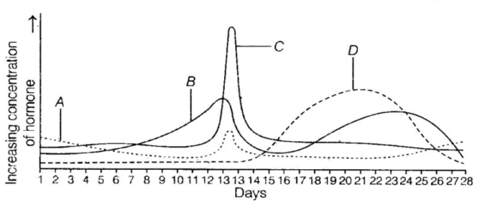The following graph of relative concentrations of the four hormones present in the blood plasma of a woman during her menstrual cycle. Identify the hormones A, B, C and D.

1. A-FSH, B-Progesterone,

C-LH, D-Oestrogen

2. A -LH, B Progesterone,

C-FSH, D-Oestrogen

3. A-FSH, B-Oestrogen,

C-LH, D-Progesterone

4. A-LH, B-Oestrogen, C-FSH, D-Progesterone

1. 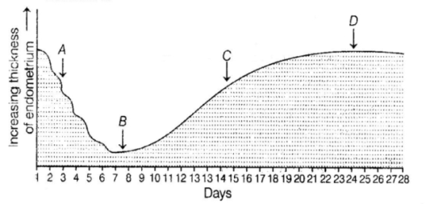The diagram shows the changes that take place in the endometrium during a normal menstruation

1. A-Ovulation; B- Menstruation

2. A-Ovulation; C-Menstruation

3. A-Menstruation; C-Ovulation

4. B-Ovulation; D-Menstruation

1. 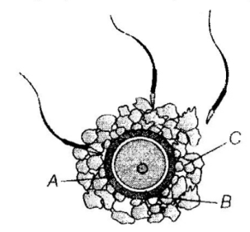The given diagram refers to ovum surrounded by few sperms. Identify A, B and C in the diagram.

1. A-Zona pellucida, B-Perivitelline space, C-Corona radiate

2. A-Zona pellucida. B-Vitelline membrane, C-Corona radiate

3. A-Zona pellucida, B-Pentivitelline space, C-Corona radiate

4. A-Oolemma, B-Perivitelline space, C-Corona radiate

1. Humans are

1. Sexually reproducing 2. Viviparous

3. Show internal fertilization 4. All these

1. Reproductive events in humans are

1. Insemination and fertilization 2 Implantation and gestation

3. Parturition 4. All these

1. Scrotum can bring down testicular temperature by

1. 2 to 2.5 degrees 2. 4-5 degrees 3.32 degrees 4. 7 degrees

1. Oogenesis is

1. Starts in embryonic ovaries 2. It’s a discontinuous process

3. It has halts like in prophase I and metaphase II 4. All these

1. Spermatogenesis is

1. Continuous process 2. Starts at puberty

3. Occurs in seminiferous tubules 4. All these

1. Identify A and B and their respective functions.

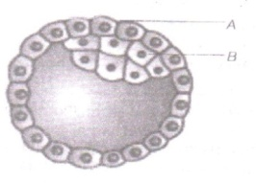

|  |  |  |  |  |
| --- | --- | --- | --- | --- |
|  | A | B | Function of A | Function of B |
| 1. | Trophoblast | Inner cell mass | Get attached to the endometrium | Differentiated as embryo |
| 2. | Inner cell mass | Trophoblast | Get attach to the endometrium | Differentiated as embryo |
| 3. | Trophoblast | Inner cell mass | Differentiated as embryo | Get attach to the endometrium |
| 4. | Ectoderm | Endoderm | Differentiated as embryo | Get attach to the endometrium |

1. 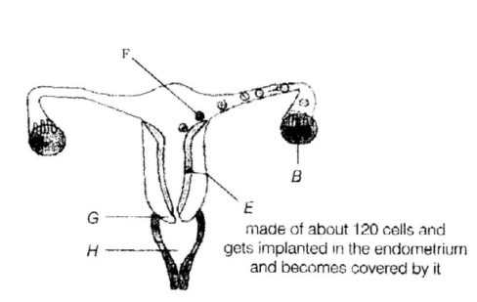Label the following diagram which illustrates the fertilisation followed by cleavage and the early stages of embryonic development Identify B E F G and F

1. B-Ovary, E-Morula, F-Blastocyst,   
 G-Cervix, H-Vagina

2. B-Ovary, E-Blastocyst. F-Morula,   
 G-Cervix, H-Vagina

3. B-Ovary, F-Blastocyst, F-Morula,   
 G-Vagina, H-Cervix

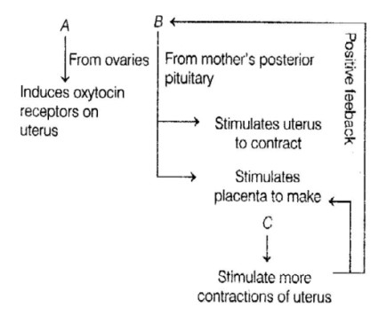4. B-Ovary, E-Blastocyst, F-Gastrula,

G-Vagina, H-Cervix

1. Name A, B, C hormones in the given figure

1. A-Prostaglandin, B-Oxytocin, C-Oestrogen

2. A-Oestrogen, B-Oxytocin, C-Prostaglandin

3. A-Oestrogen, B-Prostaglandin, C-Oxytocin

4. A-Prostaglandin, B-Oestrogen, C-Oxytocin

1. Oogenesis stops by

1. Puberty

2. 50 years

3. Its continuous it never stops

4. It stops in embryonic ovaries.

1. 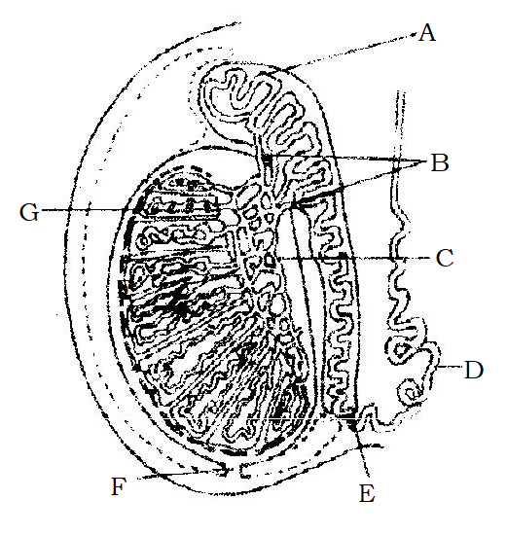The given diagram shows LS of testis showing various parts. Identify the parts labelled (A-G) from the list given below.

I. Caput epididymis

II. Cauda epididymis

III. Vas deferens

IV Vasa efferentia

V. Corpus epididymis

VI. Seminiferous tubules

VII. Tunica vaginalis

VIII Tunica albuginea

IX. Tunica vasculosa

X. Rete testis

CODES

A B C D F F G

1. II III IV X VI I IX

2. V IV III VI I X VII

3. I IV X III II VI VIII

4. I VI IV III V X IX

1. 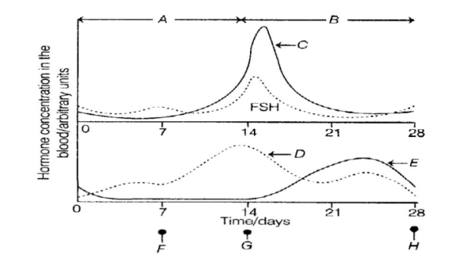The diagram shows some of the changes in blood hormone concentration which occurs during the menstrual cycle. Match, B, C, D, E, F, G and H of graph with the hormones and events given below Hormones and Events

I. Oestrogen

II Ovulation

III. Repair of endometrium

IV. Luteinising hormone

V. Menstruation

VI. Luteal phase

VII. Progesterone

VIII. Ovarian phase

CODES

I II III IV V VI VII VIII

1. H G F E D C B A

2. D E F G II A C C

3. D G F C H B E A

4. A C E G H F D B

1. Male reproductive system is constituted by

1. A pair of testes and external genitalia 2. Accessory ducts

3. Accessory glands 4. All these

1. Where is male reproductive system located?

1. In the pelvis region 2. In the abdomen

3. In the thoracic cavity 4. In between limbs

1. Shape of testis is

1. Oval 2. Polygonal 3.Tetrahedral 4. Cuboidal

1. Scrotum is

1. Bag of skin in which one finds testes 2. Covers testis

3. Accessory glands 4. Both 1 and 3

1. 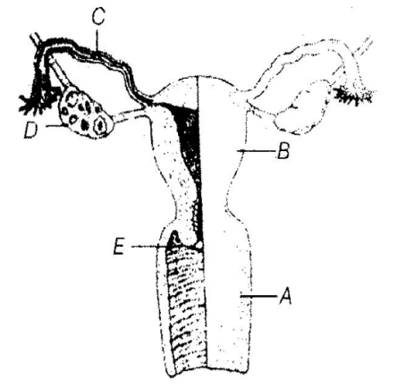Match each function below with its associated part (or parts) of the human female reproductive system shown in the figure.

I. Where is the egg produced?

II. Where does fertilisation occur?

III. Where would implantation of a fertilised egg take place?

IV. Where are oestrogen and progesterone produced?

V. What part receives the penis during copulation?

I II III IV V

1. D C B E A

2. D C B A E

3. D C B D A

4. E C B D A

1. In humans testes are

1. Extra-abdominal 2. Occur inside the abdomen

3. Occur in scrotum 4. Both 1 and 3

1. Temperature that favours spermatogenesis is

1. Lower than internal body temperature 2. Higher than internal body temperature

3. Is equal to body temperature 4. None of these

1. Testis is covered by

1. Tunica albugenia 2. Tunica media 3.Scala vestibule 4.Scala tympani

1. How many testicular lobules each testis has

1. 250 2. 150 3.350 4. 1250

1. Dimensions of testis is

1. 4-5 cm in length and 2-3cms in width 2. 3-4 cm in length and4-5cms in length

3. Both 1 and 2 4. 4-5 mm in length and 3-4 mm in length

1. Each lobule contains

1. 1-3 seminiferous tubules 2. 3-6 seminiferous tubules

3. 4-7 seminiferous tubules 4. None of these

1. How many types of cells you find inside the seminiferous tubules

1. Two types 2. Three types 3. Four types 4. Only one type

1. Male germ cells and Sertoli cells are found inside

1. Seminiferous tubules 2. Interstitial space 3. Both these places 4. Vas deferens

1. Job of sertoli cells is

1. Nutrition 2. Osmoregulation 3. Excretion 4. Secretion

1. The region outside the seminiferous tubules is called

1. Interstitial space 2. Lacuna 3. Lumen 4. Coelom

1. Leydig cells synthesize

1. Androgen 2. Estrogen 3.Zymogen 4. Progesterogen

1. The male sex accessory ducts include

1. Rete testis 2. Vasa efferentia 3.Epididymis and vas deferens 4. All these

1. Where do the seminiferous tubules of the testis open into?

1. Vasa efferentia through rete testis 2. Epididymis

3. Vas deferens 4. Urethra

1. Which accessory ducts ascends the abdomen and loops over the urinary bladder

1. Epididymis 2. Vas deferens 3.Seminal vesicle 4. Ureter

1. The urethra originates from urinary bladder and extends through the penis to its external opening called

1. Urethral meatus 2. Vulva 3.Glans 4. Anus

1. Epididymis is located along

1. Anterior surface of each testis 2. Posterior surface of each testis

3. Anterior surface of urinary bladder 4. Posterior surface of urinary bladder.

1. The enlarged end of the penis is called

1. Glans penis 2. Distal penis 3.Shaft 4. Inflammed penis

1. Loose fold of skin that covers the glans penis is called

1. Foreskin 2. Labia majora 3.Fernulum 4. Theca

1. Identify the correct path of sperm conduction from the following.

1. Rete testis → vasa efferentia → epididymis → vas deferens

2. Rete testis → epididymis → vas deferens → vasa efferentia

3. Epididymis → rete testis → vas deferens → vasa efferentia

4. Vas deferens → epididymis → rete testis → vasa efferentia

1. Which of the following are male accessory glands?

1. Seminal vesicles 2. Porstate 3. Bulbourethral glands 4. All these

1. Which of the non-reducing sugar seminal plasma is rich in?

1. Glucose 2. Galactose 3. Lactose 4. Fructose

1. Seminal plasma is rich in

1. Fructose 2. Calcium 3. Certain enzyme 4. All these

1. Major function of the bulbourethral gland is to

1. Lubricate the urethra 2. To kill microorganisms 3.To maintain the pH 4. None of these

1. Which among the following is primary sex organ in female

1. Ovaries 2. Uterus 3.Vagina 4. Cervix

1. Where are the ovaries located

1. On each side of the lower abdomen 2. On each side of stomach

3. On each side of the mammary glands 4. All these

1. Ovarian stroma is enclosed by

1. Thin epithelium 2. Very hard calcarious shell

3. Egg white 4. Thick connective tissue coat

1. Each ovary is

1. 2- 4 cms in length 2. 6-7 cms in length 3. 5 cms in length 4. 5.5 to 6.7 cms in length

1. Ovaries are connected to the pelvic wall and uterus by

1. Chordate tendinae 2. Stroma 3. Ligaments 4.Aratinoid cartilage

1. Female accessory ducts are

1. Oviducts (fallopian tubes) 2. Uterus 3.Vagina 4. All of them

1. What’s the length of fallopian tube?

1. 10-12cms long 2. 13-14cms long 3. 2cms long 4. 25cms long

1. Ovarian stroma is divided into

1. Peripheral cortex and inner medulla 2. Peripheral medulla and inner cortex

3. Outer peritheca and inner endotheca 4. Zona pellucid and inner cytoplasm

1. Fallopian tube extend s from

1. Periphery of each ovary to uterus 2. Periphery of each uterus

3. Periphery of ovary 4. None of these

1. Funnel shaped part of oviduct is

1. Infundibulum 2. Fimbriae 3.Cervix 4. Endometrium

1. During the delivery of the baby which among the following layer of uterine wall shows strong contraction?

1. Myometrium 2. Endometrium 3.Perimetrium 4. Endocardium

1. Finger like projections at the edges of infundibulum are

1. Fimbriae 2. Cervix 3.Villi 4.Valves

1. Job of fimbriae is to collect

1. Blood 2. Ovum 3. Sperm 4. Hormones

1. Which part of the oviduct has narrow lumen and joins uterus?

1. Isthmus 2. Ampulla 3.Fimbriae 4. Ligament

1. Infundibulum leads to a wider part of the oviduct called

1. Ampulla 2. Isthmus 3. Vas deferens 4. Epididymis

1. Uterus is also called

1. Womb 2. Birth canal 3. Antrum 4. Lacuna

**TOPIC: HUMAN REPRODUCTION AND REPRODUCTIVE HEALTH**

**UNIT NO: B-12**

**ANSWER KEY**

|  |  |  |  |  |  |  |  |  |  |
| --- | --- | --- | --- | --- | --- | --- | --- | --- | --- |
| **Q. No.** | **Ans.** | **Q. No.** | **Ans.** | **Q. No.** | **Ans.** | **Q. No.** | **Ans.** | **Q. No.** | **Ans.** |
| 1 | **3** | 2 | **1** | 3 | **3** | 4 | **3** | 5 | **2** |
| 6 | **2** | 7 | **3** | 8 | **1** | 9 | **3** | 10 | **2** |
| 11 | **1** | 12 | **1** | 13 | **4** | 14 | **2** | 15 | **1** |
| 16 | **2** | 17 | **2** | 18 | **2** | 19 | **4** | 20 | **2** |
| 21 | **3** | 22 | **3** | 23 | **4** | 24 | **3** | 25 | **1** |
| 26 | **4** | 27 | **2** | 28 | **3** | 29 | **2** | 30 | **3** |
| 31 | **2** | 32 | **2** | 33 | **3** | 34 | **3** | 35 | **1** |
| 36 | **4** | 37 | **4** | 38 | **1** | 39 | **4** | 40 | **4** |
| 41 | **1** | 42 | **2** | 43 | **2** | 44 | **2** | 45 | **3** |
| 46 | **3** | 47 | **4** | 48 | **1** | 49 | **1** | 50 | **4** |
| 51 | **3** | 52 | **4** | 53 | **1** | 54 | **1** | 55 | **1** |
| 56 | **1** | 57 | **1** | 58 | **1** | 59 | **1** | 60 | **1** |
| 61 | **1** | 62 | **1** | 63 | **4** | 64 | **1** | 65 | **2** |
| 66 | **1** | 67 | **2** | 68 | **1** | 69 | **1** | 70 | **1** |
| 71 | **4** | 72 | **4** | 73 | **4** | 74 | **1** | 75 | **1** |
| 76 | **1** | 77 | **1** | 78 | **1** | 79 | **3** | 80 | **4** |
| 81 | **1** | 82 | **1** | 83 | **1** | 84 | **1** | 85 | **1** |
| 86 | **1** | 87 | **2** | 88 | **1** | 89 | **1** | 90 | **1** |